**Practical no. 6**

**FS19CO042**

**Aim:** Connect computers using wireless media.

**Tool used:** Cisco Packet tracer student software.

**Required components:** Wireless router, PC, Laptop, Mobile, Tablet

**Theory and steps:**

* Wireless Router

A **wireless router** is a device that performs the functions of a [router](https://en.wikipedia.org/wiki/Router_(computing)) and also includes the functions of a [wireless access point](https://en.wikipedia.org/wiki/Wireless_access_point). It is used to provide access to the [Internet](https://en.wikipedia.org/wiki/Internet) or a [private computer network](https://en.wikipedia.org/wiki/Private_network). Depending on the manufacturer and model, it can function in a wired [local area network](https://en.wikipedia.org/wiki/Local_area_network), in a [wireless-only LAN](https://en.wikipedia.org/wiki/Wireless_LAN), or in a mixed wired and wireless network.

Wireless devices  
For a device to connect to a wireless router, it must have wireless WiFi connectivity. Most of the mobiles, tablets and laptops have in-built WiFi connectivity. Many motherboards don’t have WiFi pre-installed, hence a NIC or wireless adapter is required to connect wirelessly.

Steps for Connecting devices using wireless media are as follows:

1. 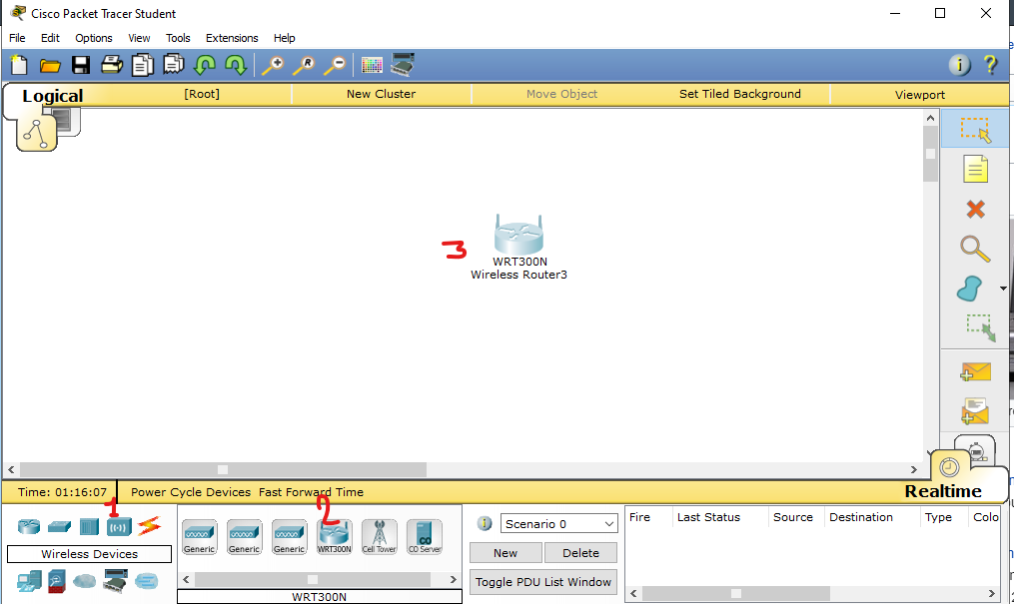From the wireless section of Devices, select Wireless router and place it on the canvas
2. 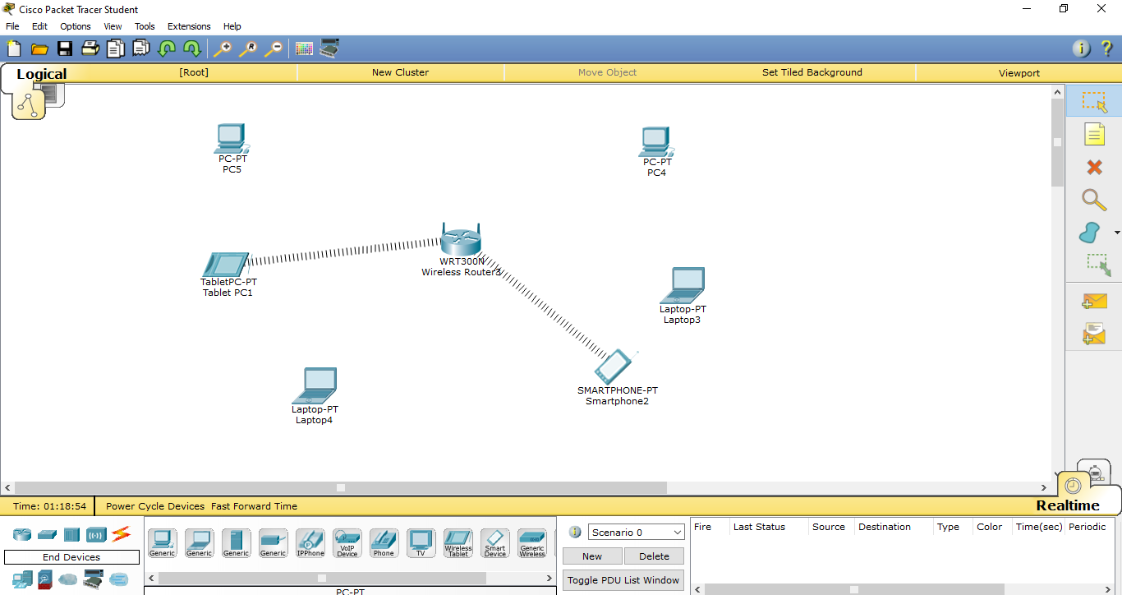Select and place desired end devices like PCs, laptops, etc  
   Devices with pre-installed WiFi auto connect the router, but generic PCs and laptops need to have NIC swapped by those which support wireless connectivity.
3. 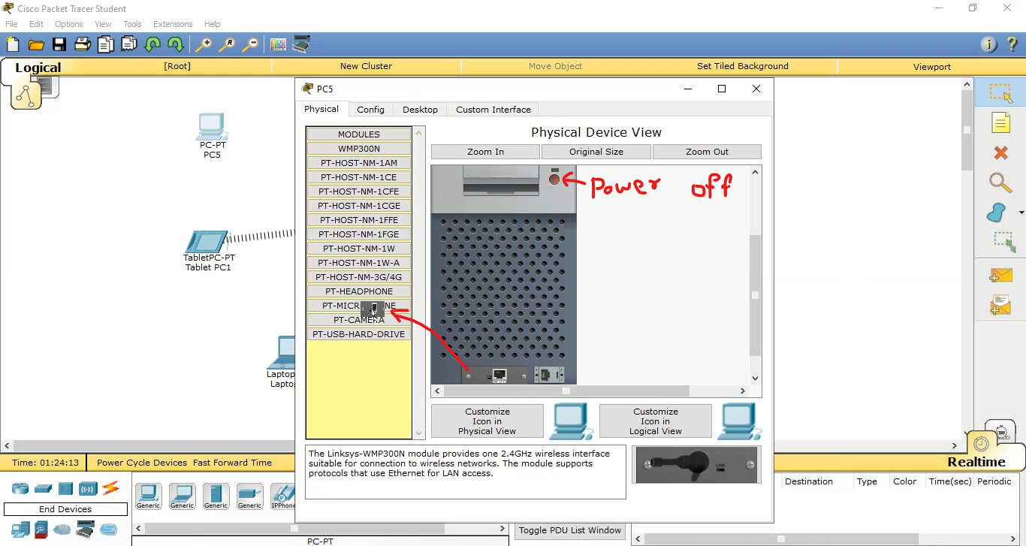Configuring PC for wireless connection:  
   Click on a PC and navigate to Physical tab. Turn PC power off and drag existing network module to module tray on left:  
     
     
     
     
     
     
     
     
     
     
     
     
     
     
   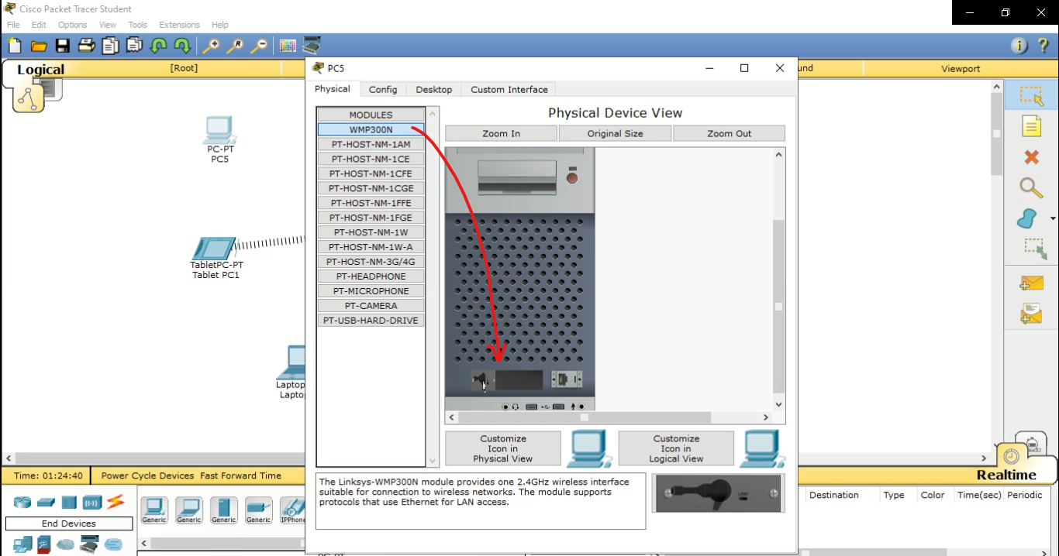Drag the WMP300N module from modules tray to empty module section of PC  
     
   Thus, module is swapped, now turn on the power and close PC window. PC will automatically connect to Wireless router after few seconds  
   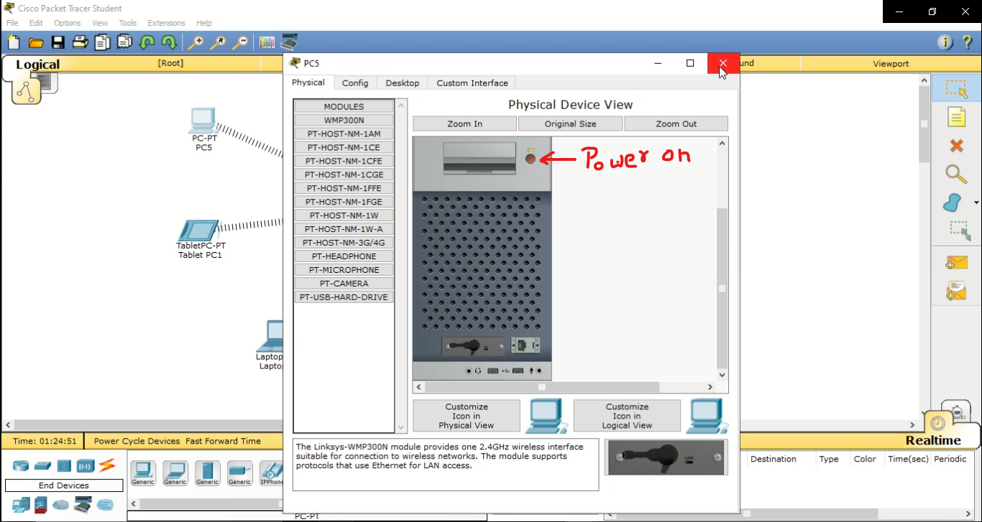
4. 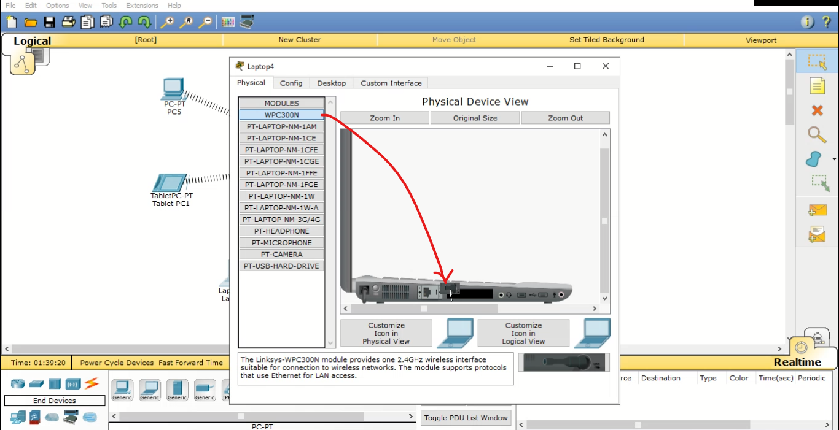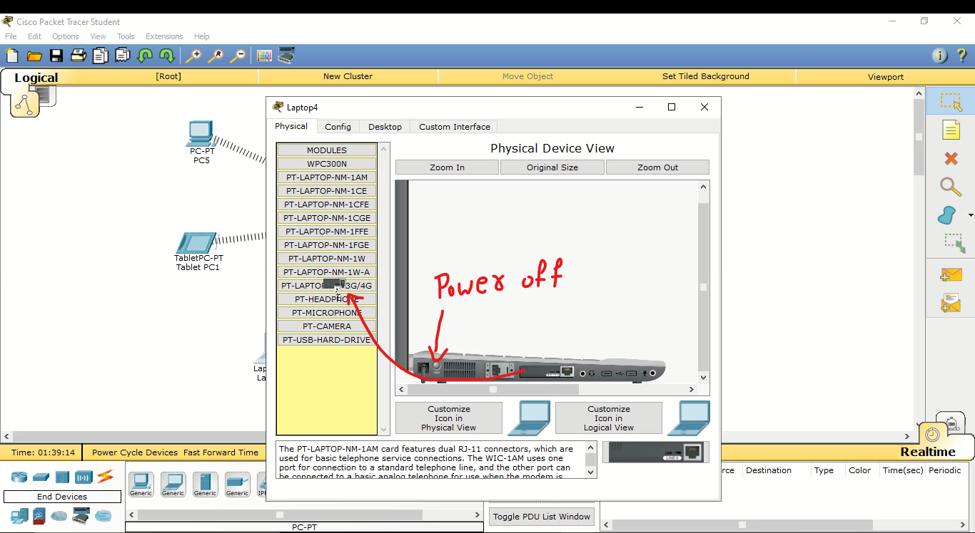Configuring laptops for wireless connectivity  
   Similar to PC, turn off power and swap the default module in laptops with WMP300N module. Again power on laptop
5. 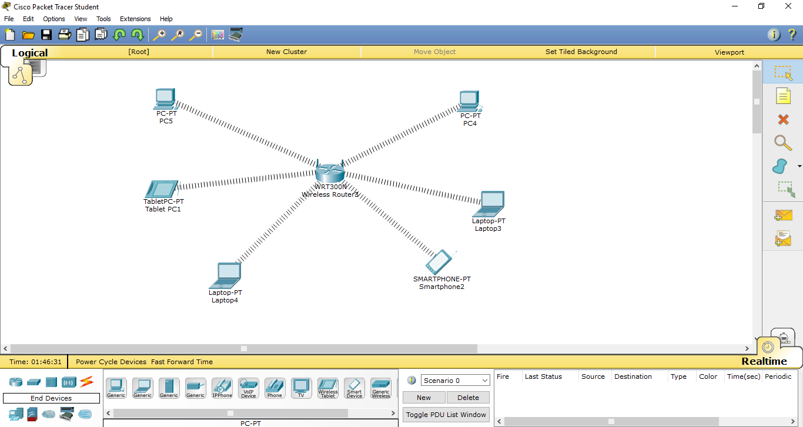Similarly swap network modules of other laptops and PCs and after some time, all of them will be connected to router automatically.
6. 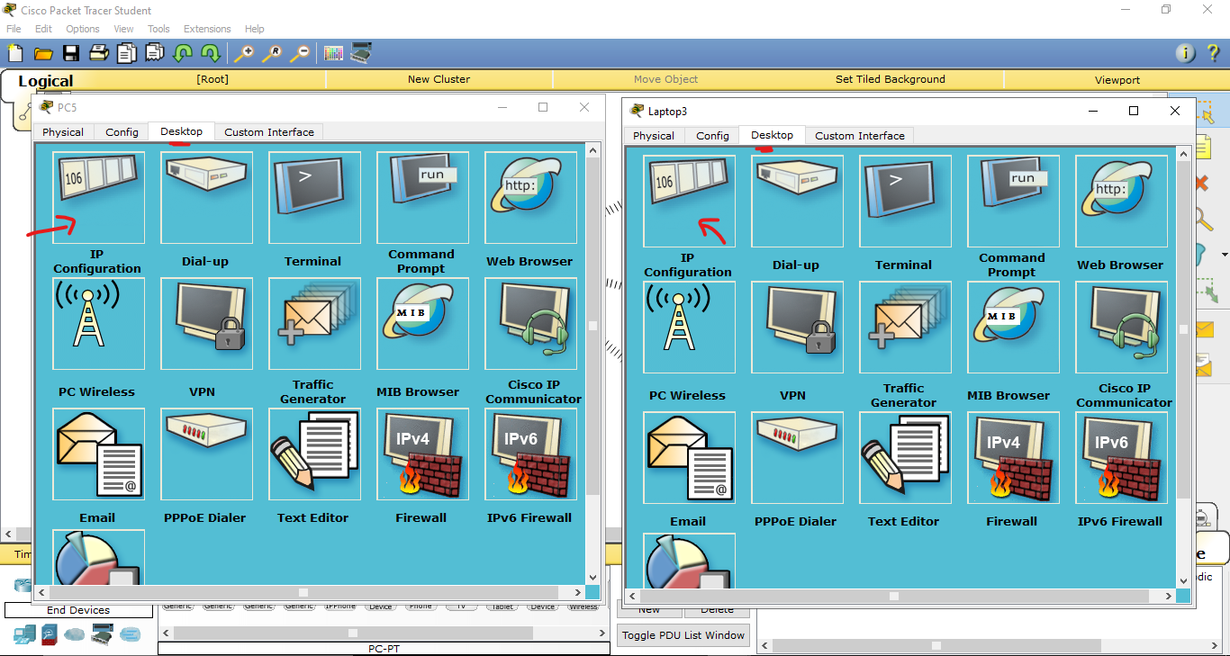Setting up static IP addresses (Optional)  
   By default every device is assigned a unique dynamic IP by router, we can set up unique static  
   Open PC or laptop and under Desktop tab select click on IP configuration  
     
     
     
     
     
     
     
     
     
     
   Select Static IP and enter unique IP address for every device  
     
   Close the window  
   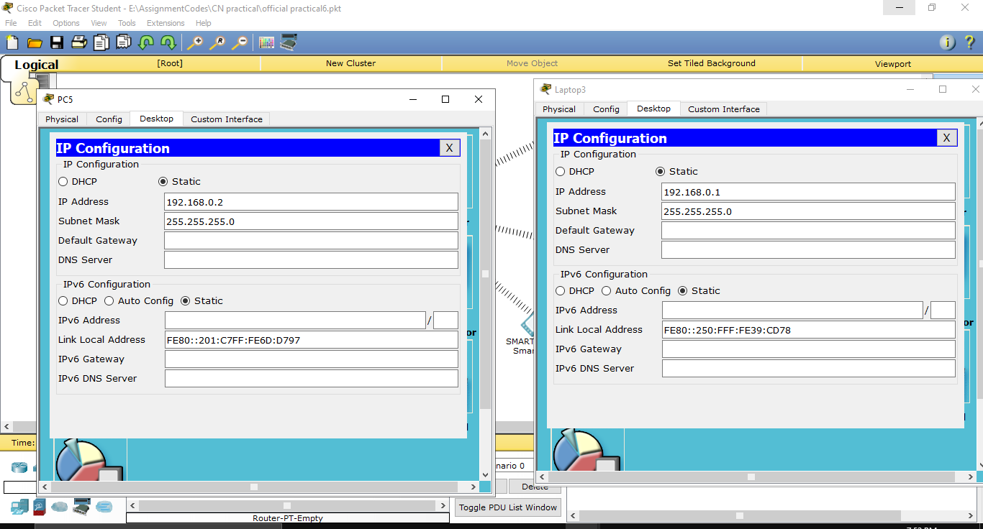Similarly, allocate unique IP addresses to other devices too.
7. 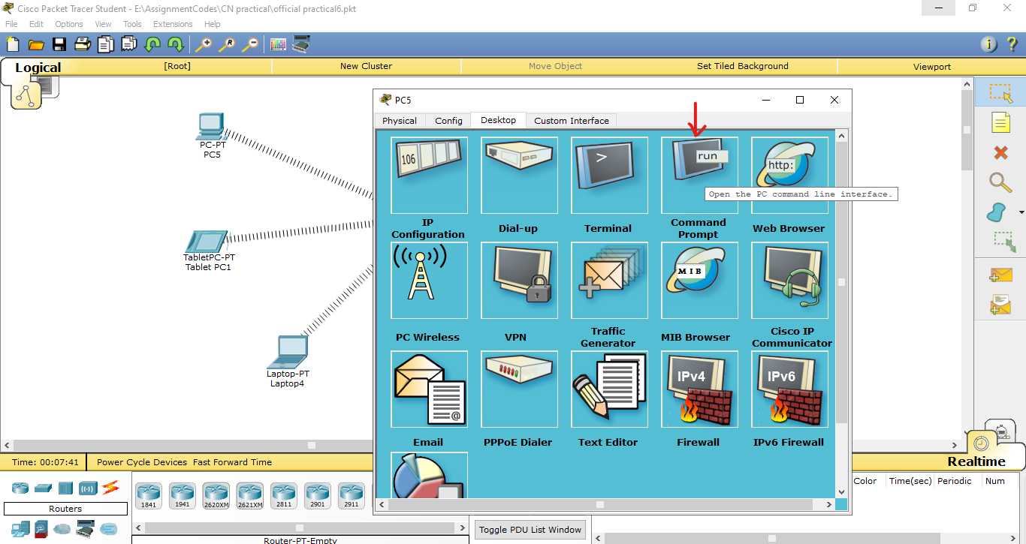Checking connection by pinging other devices from command promp  
   Click on any device and under desktop, click on Command prompt  
     
     
     
     
     
     
   Enter the following cmd: **ping <valid IP>** for example, ping 192.168.0.1  
   If the IP is valid, you’ll see a successful reply message.  
     
   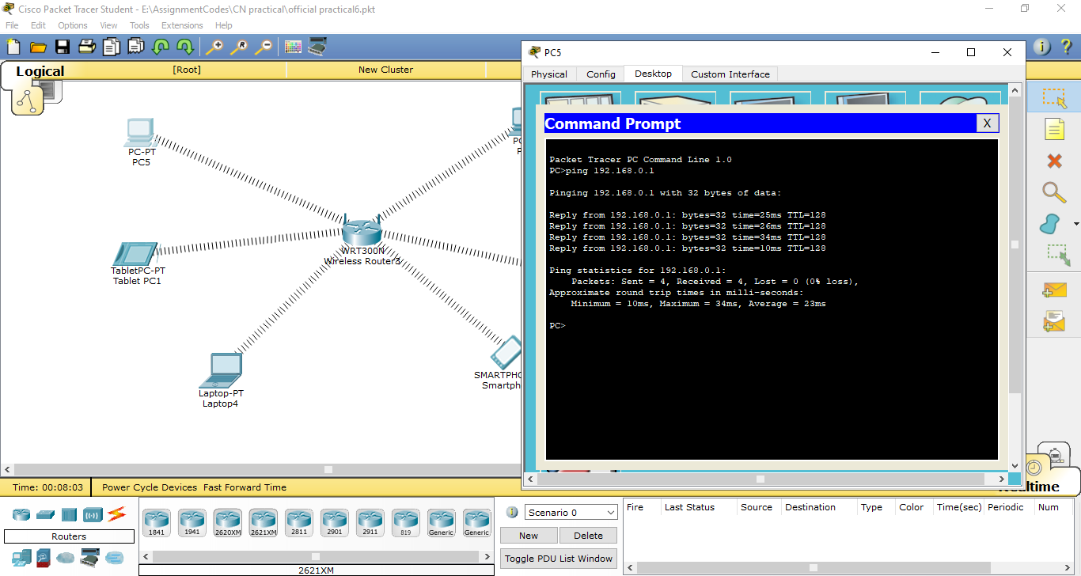
8. 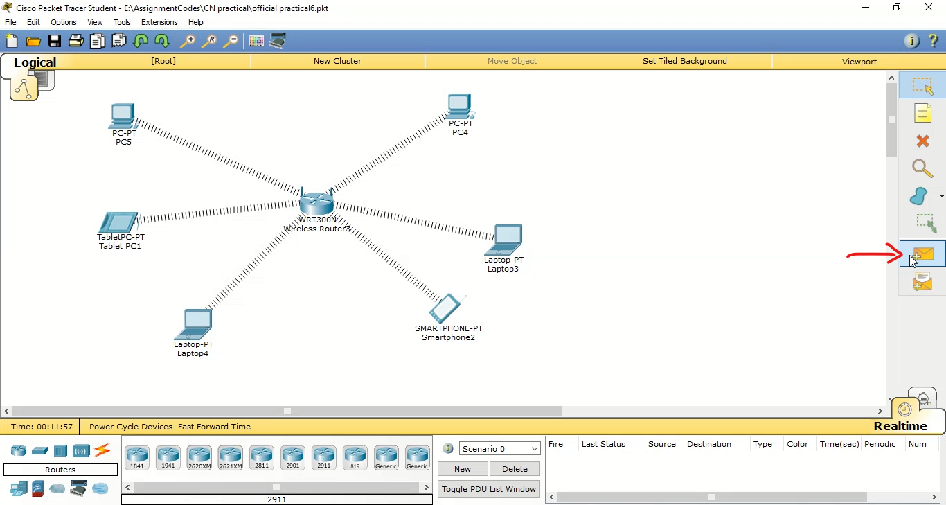Checking connection by sending packets through Cisco packet tracer GUI  
   Select packet on right hand side toolbar  
     
     
     
     
     
     
     
     
     
   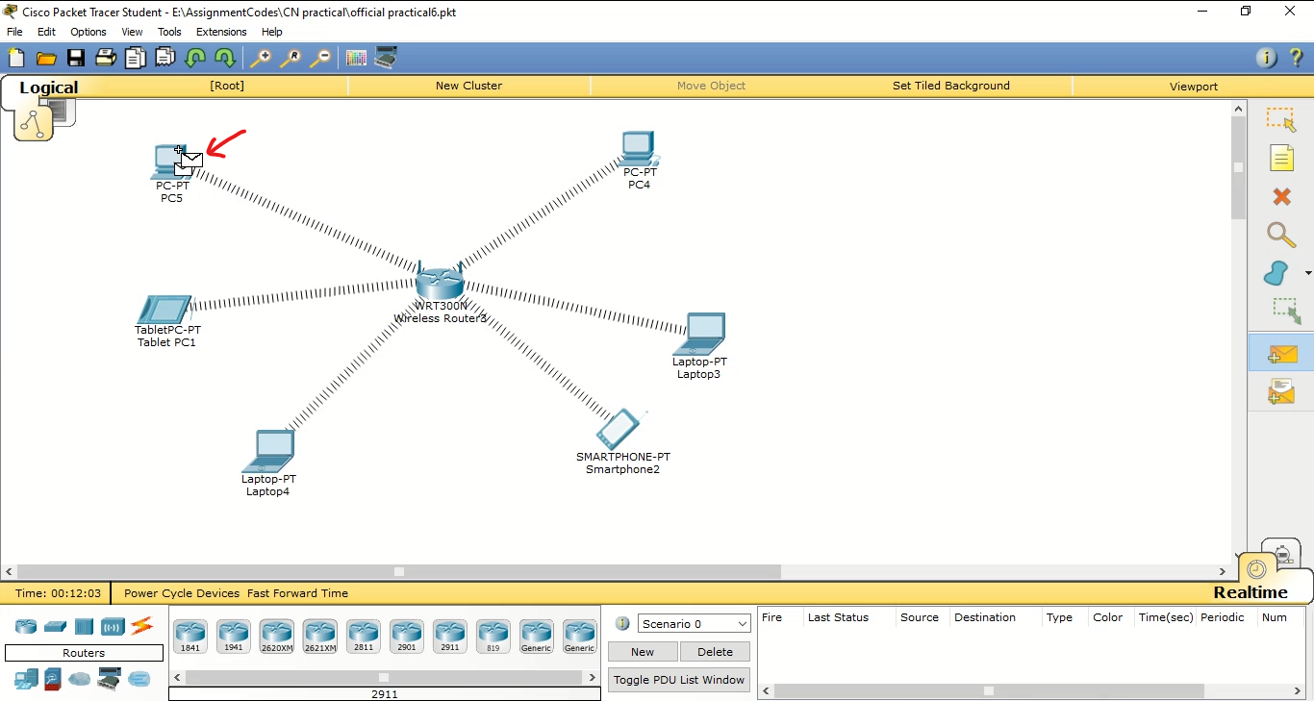Click on source device to dispatch packet  
     
     
     
   Click on target device that receives packet  
     
     
     
   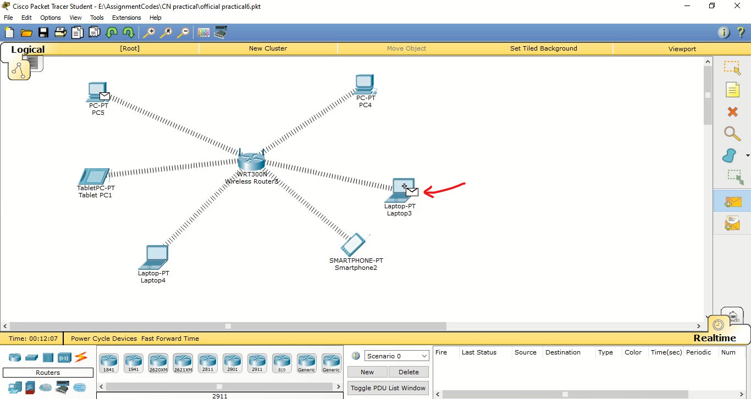  
     
     
     
     
     
     
     
     
     
     
     
     
   If the IP addresses and connections are properly configured, a Successful status is shown, similarly check connection across other devices  
   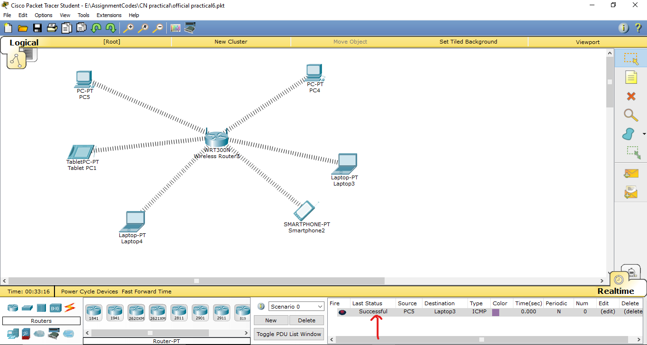

**Conclusion:** Thus, we connected computers and other devices using wireless media